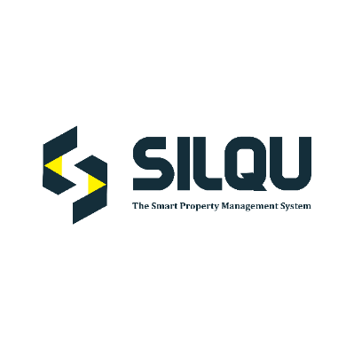
ACCOUNT REGISTRATION FORM

1.USER ACCOUNT DETAILS.

SYSTEM USER 1 NAME: |  | MOBILE NUMBER:
SYSTEM USER 2 NAME: |  | MOBILE NUMBER:
ID/PASSPORT NUMBER: | 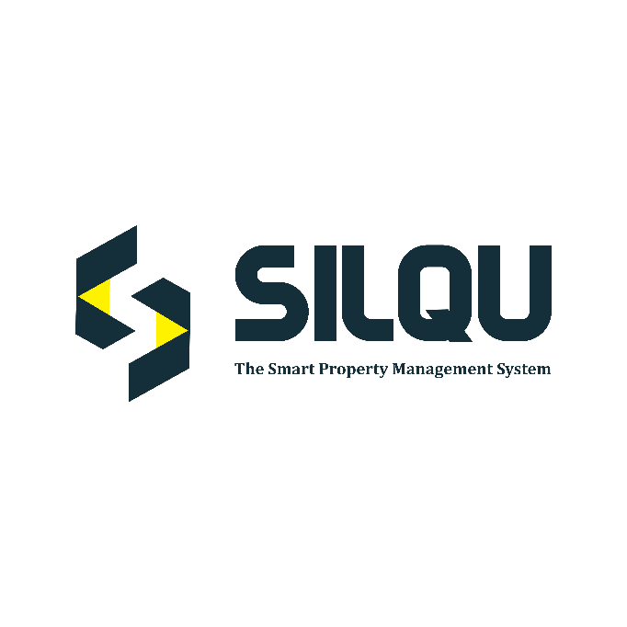Landlord/Owner | EMAIL ADDRESS:
DESIGNATION:  (click box as appropriate) | ☐ | ☐ | ☐  Other:  Manager/Agent

2. PROPERTY INFORMATION
PROPERTY NAME: | Residential | LOCATION:  Commercial | Other:
TYPE:  (click box as appropriate) | ☐ | ☐ | ☐
TOTAL NO. OF UNITS: |  | DO YOU HAVE MORE THAN ONE PROPERTY?
CONTACT PERSON NAME: |  | CONTACT PERSON NUMBER:

☐ I/we Hereby certify and confirm that the information provided in this form is complete, true and correct to the best of my knowledge. By submitting this form, you agree to our Privacy Policy and Terms and conditions

Data Protection.
In compliance with the Data Protection act, the information you provide on this page will be used by us exclusively for the purposes of normal business and will not be disclosed to any third party.

SIGNATURE: …………………………………… DATE:
……………………….

FOR OFFICIAL USE ONLY.
Received by: Signature:
…………………………………………………….
Designation:
…………………………………………………..
Once Filled correctly, please share the form via info@silqu.com or WhatsApp 0717888828/0787888828.
The content of this document is confidential and intended for the recipient specified in message only. It is strictly forbidden to share any part of this message with any third party, without a written consent of the sender. If you received this document by mistake, please call +254717888828 or info@silqu.com so that we can ensure such a mistake does not occur in the future.

